Crazy Delivery

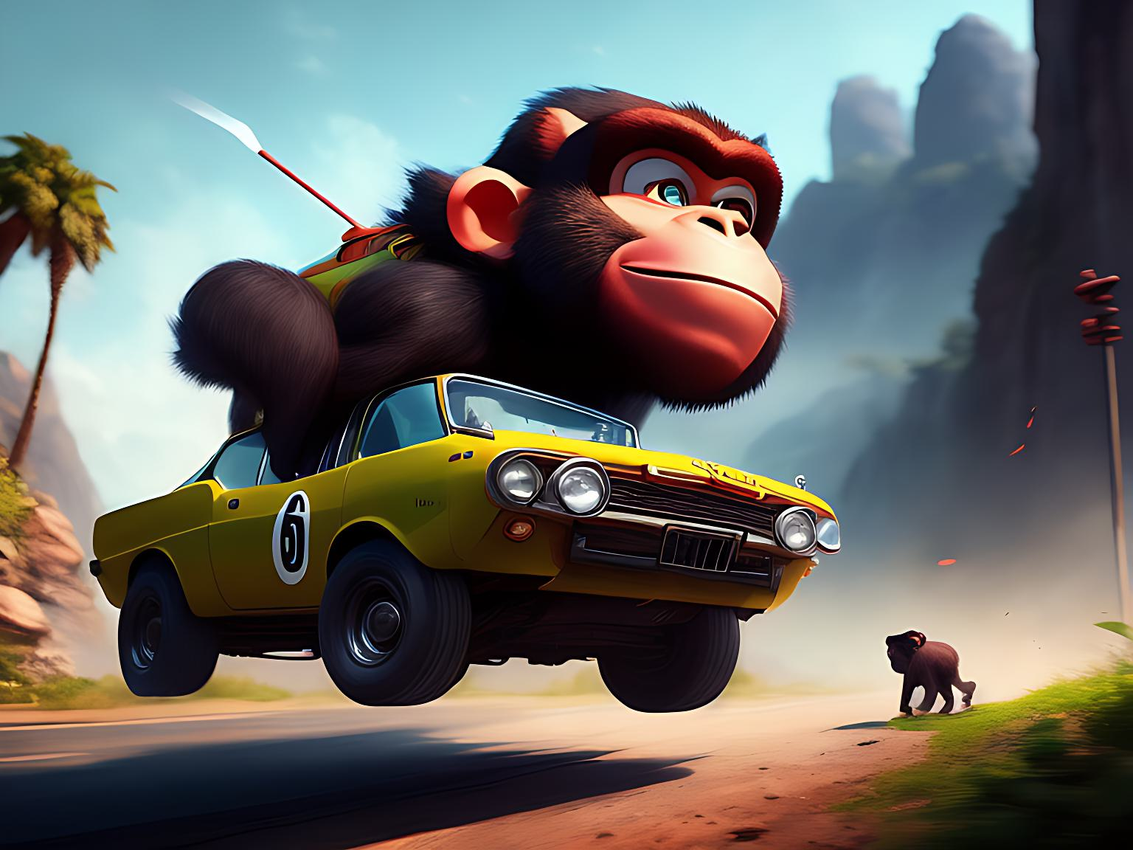

Computer Graphics Project - Final Phase

Under Supervision Of

ENG. Yahia

Workload

|  |  |  |
| --- | --- | --- |
| Beshoy Morad Atya | Sec: 1 | BN: 20 |

|  |  |
| --- | --- |
| Phase 1  Shader,  Mesh,  Pipeline State,  Texture,  Sampler | Phase 2  Building the map,  Lighting,  Collision System,  Battery handler System, Delivery System,  Radio System |

|  |  |  |
| --- | --- | --- |
| Abdelrahman Hamdy | Sec: 1 | BN: 36 |

|  |  |
| --- | --- |
| Phase 1 | Phase 2 |

|  |  |  |
| --- | --- | --- |
| Abdelrahman Noaman | Sec: 2 | BN: 2 |

|  |  |
| --- | --- |
| Phase 1 | Phase 2 |

|  |  |  |
| --- | --- | --- |
| Yousef Khaled Alwaer | Sec: 2 | BN: 37 |

|  |  |
| --- | --- |
| Phase 1 | Phase 2 |

Screen Shots

1. Main Menu

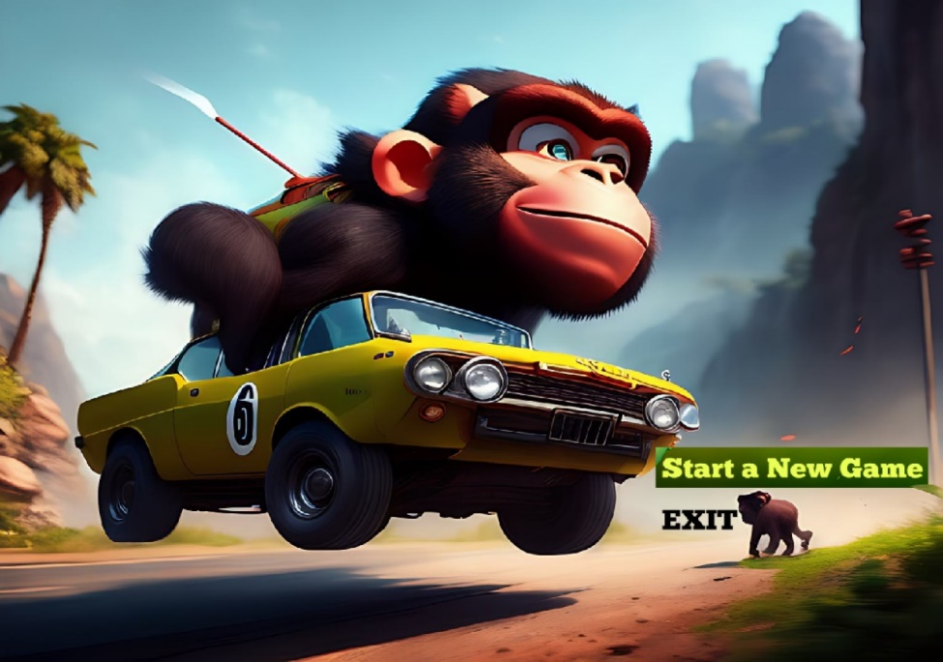

1. Win State



1. Lose State

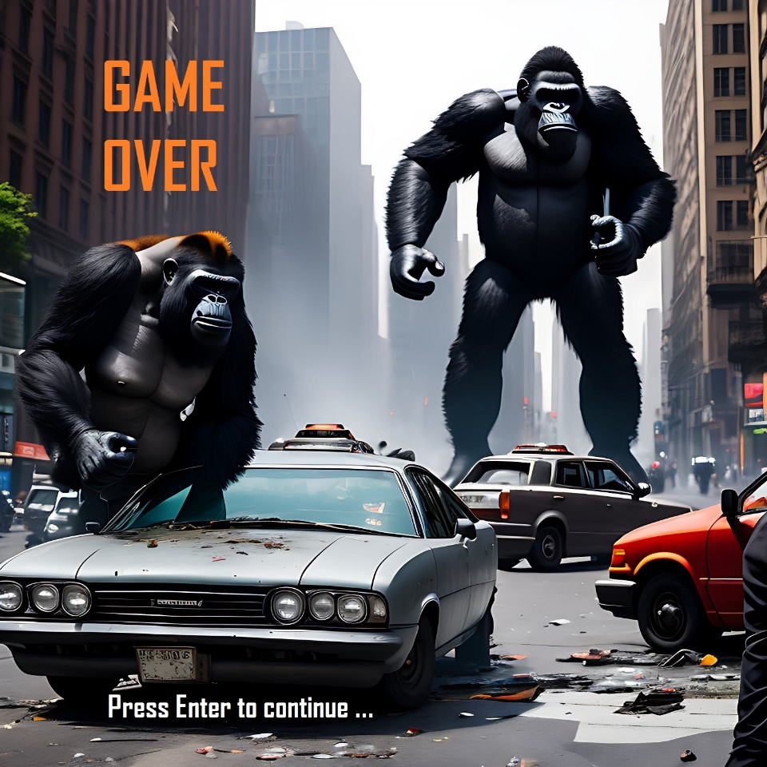

1. Game Screenshots